**Nov 2016 SL P1**

**Section A**

1. State **three** potential usability issues with cell phones. [3]
2. (a) State the purpose of cache memory. [1]  
     
     
     
     
   (b) Draw a diagram to show the relationship between random access memory (RAM),

the processor and cache memory. [1]

1. Outline **one** advantage and **one** disadvantage of wireless networks. [4]
2. Construct a truth table for the Boolean expression not (A xor B) and C.

Use the following headings in your table.

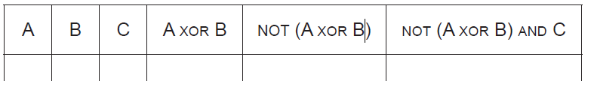 [4]

1. Many different people and organizations upload scientific materials to the internet.

A student uses data from the internet in a science project.

Outline **two** ethical issues concerning this use of the internet. [4]

1. Consider the following algorithm that inputs X and N, and outputs P.

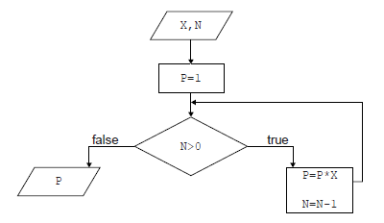

1. Determine how many times multiplication is performed when this algorithm is executed. [1]
2. Construct a trace table for the algorithm when X=2 and N=4. Use the following

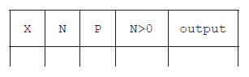headings in your table.   
  
  
  
  
  
 [4]

1. State the purpose of this algorithm. [1]
2. Outline the features of a virtual private network (VPN).

**Section B**

1. A book shop has a computer at each point of sale, and also a central computer.

When a customer buys a book in the book shop, the salesperson at the point of sale uses a

scanning device to input a barcode from the book.

The barcode is sent to the central computer where the barcode of each book and the

corresponding price are held in a database on a disk.

When the price is found, it is sent to the point of sale computer where all necessary

calculations are performed, details of the transaction are stored on a local disk and a receipt

is printed out.

1. Construct a system flow chart for the system described above. [5]

At the point of sale there are peripheral devices other than the scanning device and printer.

1. Outline the purpose of **one** other possible peripheral device in this scenario. [2]

The customers can also buy books online. A customer can select a book, and then enter  
 their name, address and credit card number. This data is stored on the book shop’s  
 central computer in a database of customer orders.

1. Outline the purpose of protocols in transferring this data. [2]
2. (i) Identify **two** sources of risk to personal data in this online system. [2]

(ii) State **two** measures that the book shop can take to address the risks identified

in part (d)(i). [2]  
  
  
(iii) Outline the consequences to the customer if their data is not adequately protected. [2]

1. A new higher level programming language is being developed.
2. Identify **two** reasons why consistent grammar and syntax should be essential features

of a higher level programming language. [2]

1. Identify **two** features of a user interface that will allow application programmers to

interact more easily with the programming language. [2]

1. State one method of providing user documentation. [1]

Application programmers who use this programming language will be able to choose to use  
 either an interpreter or a compiler.

1. (i) Outline the need for an interpreter or a compiler. [2]  
     
     
     
   (ii) Describe one advantage to application programmers of having both an

interpreter and a compiler available. [2]

One of the predefined sub-programs in the new language is sumOdd(). It accepts an integer  
 N as input. If N<=0 it outputs -1, otherwise it outputs the sum of the first N odd numbers.

For example:

sumOdd(4) outputs 16, because 4 is not less than 0, and 1 + 3 + 5 + 7 = 16.

sumOdd(−3) outputs −1, because −3 is less than 0.

1. Construct, in pseudocode, the algorithm for sumOdd(). [4]
2. Outline the need for predefined sub-programs and collections. [2]
3. In a school there are 2400 students and each student uses one locker. Each locker has a unique

number from 1 to 2400.

The lockers are to be painted in four colours: red, white, yellow and blue, in order of locker

numbers, as shown in the following table.

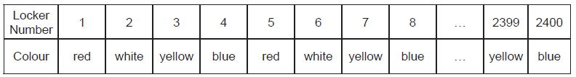

The pattern of colours continues in this manner. For example, locker number 15 will be  
painted yellow.

1. State the colour that locker number 442 will be painted.

Each student is responsible for painting his or her locker. Some students do not know how  
to determine the colour they should use.

1. Construct, in pseudocode, an algorithm that accepts a locker number as input,

and outputs the colour that this locker should be painted.

Three arrays are used to hold the following information:

• the names of students in alphabetical order, are held in the array STUDENT_NAME[];

• the corresponding locker number is held in the array LOCKER_NO[];

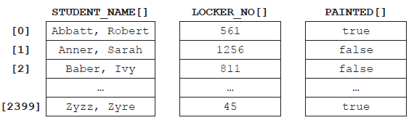• whether the locker has been painted or not is held in the array PAINTED[].

For example STUDENT_NAME[1] is Sarah Anner. She is responsible for locker number 1256  
and this locker has not been painted yet.

1. (i) State the name of the student who is responsible for painting locker number 811. [1]  
     
     
     
     
     
   (ii) Construct, in pseudocode, an algorithm that counts and outputs the number of  
    lockers that have been painted so far. [4]
2. Describe an efficient algorithm, which accepts a student’s name as input, and outputs

the corresponding locker number and whether or not it has been painted. [4]